**Department of Veterans Affairs (VA)**

**VA Software Document Library (VDL)**

**Manager User Guide**

**Version 5.0**

**July 2022**

**Department of Veterans Affairs**

**Office of Development, Security, and Operations**

**Revision History**

|  |  |  |  |
| --- | --- | --- | --- |
| **Date** | **Version** | **Description** | **Author** |
| 7/1/22 | 5.0 | 1. Consensus of VDL Tech   Writers to no longer put _r (for redaction) on original manuals.   1. Line spacing changed to 1.5 in order for _r to appear in document. | VA Software  Document Library  Administrators,  VistA Office |
| 3/31/22 | 4.0 | Corrected link for VDL Managers access; Added information regarding:  Archive Folders  Editing Folder  Added a glossary, page numbers.  Updated Checklist Reference for posting.  Reformatted guide to be in line with OIT Documentation Style Guide. | VA Software  Document Library  Administrators,  VistA Office |
| 6/15/21 | 3.0 | Updated VDL Manager site address; Added sections:  Revisions and Versioning,  Deletion and/or Removal,  Decommissioned Systems and/or Software, Publishing  Process from the VDL Manager | VA Software  Document Library  Administrators,  VistA Office |

|  |  |  |  |
| --- | --- | --- | --- |
| **Date** | **Version** | **Description** | **Author** |
|  |  | to the VDL; Revised/updated: graphics throughout, Reference section; Revised/expanded sections: 508 conformance instructions, Document  Retention Standards, Edit this  Application’s Display section,  Document Size restrictions, Document Type Requirements;  Revised/expanded/reorganized:  Using the VDL Manager; Removed references to the monograph |  |
| 2/19/21 | 2.0 | Duties of VA Software  Document Library  Administrators assumed by VistA Office; document renamed and restructured; incorporated VA Software  Document Library  Standard Operating Procedure  – User content; rescinded VA  Software Document Library  Standard Operating Procedure – User document; expanded instructions throughout; Added disclaimers, additional graphics, List of Figures, User  Agreement, employee | VA Software  Document Library  Administrators,  VistA Office |

|  |  |  |  |
| --- | --- | --- | --- |
| **Date** | **Version** | **Description** | **Author** |
|  |  | information in Sensitive Data  Prohibitions, Redaction Requirements, author requirements, Document Naming Conventions,  Document Format standards, Document Retention requirements, References section, footnotes, all  Appendixes; Updated support email name and address; updated or removed outdated references and links, graphics, and figures |  |
| 6/12/19 | 1.4 | Update support email address | Rational Tools  Team (RTT) |
| 4/8/19 | 1.3 | Updated first bullet in Section  4.5 File Naming Convention | Rational Tools  Team (RTT) |
| 6/14/18 | 1.2 | Raised to current documentation standards | Rational Tools  Team (RTT) |
| 6/14/17 | 1.1 | Update content, tech/508 edit | Rational Tools  Team (RTT) |
| 6/12/12 | 1.0 | Initial draft |  |

**Table of Contents**

1 Introduction 1

2 User Agreement 1

3 Sensitive Information 2

4 Sensitive Information Prohibitions 3

5 Redaction Requirements and Examples 4

5.1 PII Format Examples 5

5.2 Internal Information Format Examples 6

6 Section 508 Conformance 7

7 Document Retention Standards 8

7.1 Revisions and Versioning 8

7.2 Deletion and/or Removal of Artifacts 9

7.3 Archive Application Folders 9

7.4 Decommissioned Systems and/or Software 10

8 Document Standards for End User Documents 10

8.1 Document Format Guidelines 10

8.2 Document Type Requirements 10

8.3 Document Size Restrictions 11

8.4 Document Authorship/Properties Guidelines 11

8.4.1 Acceptable Authorship 12

8.4.2 Changing Author Settings for Microsoft 12

8.4.2.1 Setting Author in .docx Options 12

8.4.2.2 Document Properties/Author Information .docx Instructions 13

8.4.2.3 Document Properties/Author Information .pdf Instructions 15

8.5 Internal File Naming Conventions 16

8.6 External Document Naming Conventions 18

9 Using the VDL Manager 19

9.1 VDL Manager Access 19

9.2 Using the VDL Manager 21

9.3 Managing Artifacts/Documents on the VDL Manager 22

9.3.1 Adding a New Artifact/Document 23

9.3.2 Editing an Existing Artifact/Document 25

9.3.3 Deleting an Existing Artifact/Document 26

9.3.3.1 Delete ALL Documents 26

9.3.3.2 Delete One Document Using the Edit page 27

9.4 Moving Artifacts to Archive Folders 28

9.5 Editing Application Details 29

10 Publishing Process: Promoting Artifacts from VDL Manager to the VDL 30

11 Errors and Getting Help 32

12 Documentation Disclaimer 32

13 Glossary 32

14 References 33

15 Attachments 34

Attachment 1 Quick Artifact Content Checklist - Prior to Posting 35

Attachment 2 Quick Artifact Property Checklist - Prior to Posting 38

Attachment 3 Quick Artifact Checklist - After Posting 40

Attachment 4 VDL Document Review Findings 41

Table of Figures

Figure 1: Ensure These Functions Are OFF ................................................................................... 7

Figure 2: Check Accessibility Function in MS Office for Word .................................................... 8

Figure 3: Accessibility Tool in Adobe For PDF ............................................................................. 8

Figure 4: Acceptable Author Information Example ..................................................................... 12

Figure 5: Options in .docx ............................................................................................................ 13

Figure 6: Personalize Copy of MS Office..................................................................................... 13

Figure 7: Select Info in .docx ........................................................................................................ 14

Figure 8: Verify Author Properties in .docx ................................................................................. 14

Figure 9: .docx Author Instructions .............................................................................................. 14

Figure 10: .pdf Author Instructions .............................................................................................. 15

Figure 11: Edit .pdf Author ........................................................................................................... 15

Figure 12: VDL Manager Service Request Form ......................................................................... 20

Figure 13: VDL Manager Home Screen and Login...................................................................... 21

Figure 14: VDL Manager Home Page with List of Application Links ........................................ 22

Figure 15: Typical Application Display ....................................................................................... 23

Figure 16: Add A New Document Link ....................................................................................... 23

Figure 17: Add A New Document ................................................................................................ 24

Figure 18: Document Uploaded Successfully Message................................................................ 24

Figure 19: Unable to Upload File Message .................................................................................. 24

Figure 20: Add Next File to Document ........................................................................................ 25

Figure 21: Verification Both Files Are Loaded ............................................................................ 25

Figure 22: Upload Files Screen Showing Base Filenames are the Same ..................................... 26 Figure 23: Last Updated Date Displayed ...................................................................................... 26

Figure 24: Delete an Existing Entry, Including ALL Documents ................................................ 27

Figure 25: Deletion Warning of Document and ALL Files .......................................................... 27

Figure 26: Delete Files from Edit Page......................................................................................... 27

Figure 27: Deletion Warning of One File ..................................................................................... 27

Figure 28: Edit this Application's Details ..................................................................................... 29

Figure 29: Editing the Name and/or Version Information ............................................................ 29

Figure 30: Automatically Generated Email .................................................................................. 30

Figure 31: Response on Original Email with Incident Ticket Number ........................................ 31

Figure 32: VDL Administrator Email Reponses when Ticket has been Resolved ....................... 31

# Introduction

The VA Software Document Library (VDL) is a public facing repository which stores and makes available *redacted* reference materials[1] regarding released VistA Class I software applications in the VA. The VDL Manager is an application internal to the VA used to update and maintain the redacted documents found on the VDL.

This user guide provides instructions on how to use the VDL Manager website to update the artifacts2 stored on the VDL website and supersedes all previous versions of this document, as well as the VA Software Document Library Standard Operating Procedure – dated July 2019.

Instructions are also located on the [VDL Service Management (sharepoint.com)](https://dvagov.sharepoint.com/sites/OITEPMOVistAOffice/SitePages/VDL-Service-Management.aspx) SharePoint Site.

Please note, it is the responsibility of the publishing user of the document(s) for any end user documentation published to the VDL to ensure this guide is followed. Users not complying with the standards of this document will forfeit access to the VDL Manager.

While all artifacts on the VDL must be redacted, users internal to the VA may need the original, unredacted software documentation. The unredacted artifacts are located on the internal software directory located at [https://download.vista.med.va.gov/index.html/SOFTWARE/.](https://download.vista.med.va.gov/index.html/SOFTWARE/) Even though the VDL Administrators are not responsible for the artifacts posted to or the maintenance of the internal software directory, they may need to remind users posting to the internal directory and/or the VDL Managers of the appropriate posting process for software documentation.

***DISCLAIMER:*** *This document is intended for internal VA use only; hence, it contains links to VA Intranet sites not available to the public. This guide should not be made available to anyone outside of the VA.*

# User Agreement

By requesting and receiving access to the VDL Manager site, users agree to adhere to the guidelines and procedures set forth for artifact publication. In addition, users agree to participate, assist, and perform tasks necessary to review documents for appropriateness, standards

compliance, accessibility, and other administrative functions needed to ensure the VDL adheres to VA standards and policies. Yearly reviews of authorized users will be performed by the VDL Administrators which will require users to verify the need for access to the VDL Manager and specific sections remains. Reviews will also be performed to ensure spelling, grammar and acronyms are correct. As the VDL is a public facing site, it is important the documents do not contain misspellings and other typographical errors. Publishers of artifacts to the VDL should strive to update any existing (legacy/archive) documents following the current documentation standards and style guidelines when revisions are made to preexisting documents.

VDL Administrators will send the users a VDL Document Review Findings report, if artifacts require correction. Users will be given seven days to make corrections and upload the corrected artifact. Documents not conforming to the standards outlined in this document will be removed from the VDL until corrections are made. An email will be sent to the user’s supervisor alerting them to the removal of the document.

# Sensitive Information

All data presented in user documentation, presentations, or any other artifacts prepared for publication to the VDL must follow the VA’s standards regarding sensitive information. These standards include, but are not limited to, the Displaying of Sensitive Data Guide and the OIT

End-User Documentation Standards. The most current versions can be found on the Process Asset Library (PAL) Artifacts Library.

As found in the Displaying of Sensitive Data Guide, the official warning regarding the displaying of sensitive information is:

**“The information posted in our library must not contain any privacy-protected data or information that may be deemed sensitive and/or classified at any time. No single document in the VDL should contain any individually identifiable information or information of a personal nature. Your team is ultimately responsible for making sure the document(s) to be uploaded have been properly de-identified and do not contain any personal information. By uploading a file to the library, you are confirming that no privacy-protected data or sensitive or personal information exists on such file, and that the file is not deemed as identifiable or classified information by the US Government.”**

NOTE: Basically use common sense when reviewing for PII. If there is anything that could even remotely be traced back to an employee, veteran, medical center, etc., redact it.

# Sensitive Information Prohibitions

In accordance with standards of sensitive information prohibitions, the following area provides guidance for VDL documentation.

1. No Personally-Identifiable Information (PII) as defined in OMB Memorandum M-07-

16, Port Numbers; IP Addresses, Uniform Resource Locators (URL), Fully Qualified

Domain Names (FQDN), Mail Groups used to receive data; Personal Health

Information (PHI), nor any VA sensitive operational data pertaining to all individuals, including veterans, dependents, employees, contractors, is to be stored in data records or in documents with the VDL tools repositories as identified in the “Displaying Sensitive Data Guide” (End User Documentation Standards, December 2019). This is a requirement, like those established if using VA Service Desk tools and other tool repositories used during VA work activities. The following examples are not a complete list of prohibited information; however, these are some of the most found elements which must be redacted from documentation posted to the VDL.

* 1. Personally Identifiable Information (PII) examples:
     1. Patient identifier examples: name and or initials, address, phone numbers, Social Security Number (SSN), next of kin (NOK), etc.
     2. Employee identifier examples: name and or initials, address, phone numbers, Social Security Number (SSN), work address, email address
     3. Provider numbers/license numbers
     4. Clinic names which include provider/employee name
  2. Internal Information
     1. Download/FTP site addresses (Albany, Hines, SLC, etc.)
     2. Port Numbers
     3. Server names and/or addresses
     4. Intranet website addresses/URL and/or links
     5. Internal VA website addresses/URL and/or links
     6. SharePoint Site addresses and/or links
     7. Phone numbers and email addresses

1. The VA National Rule of Behavior (ROB) uses the phrase “VA sensitive information.” This phrase is defined in VA Handbook 6500, Appendix D. This definition covers all information as defined in 38 U.S.C. 5727(19), in 38 U.S.C.7332 and in 38 U.S.C.5727(23). The phrase “VA sensitive information” as used in the VA National ROB means:
   1. All Department data, on any storage media or in any form or format, which requires protection due to the risk of harm that could result from inadvertent or deliberate disclosure, alteration, or destruction of the information. The term includes information whose improper use or disclose could adversely affect the ability of an agency to accomplish its mission, proprietary information; records about individuals requiring protection under various confidentiality provisions such as the Privacy Act of 1974 and the HIPAA Privacy Rule; and information that can be withheld under the Freedom of Information Act (FOIA).
   2. Examples of information that could be considered VA sensitive information depending on the specific circumstances, include the following: individually identifiable medical, benefit, and personnel information; financial; budgetary; research; quality assurance; confidential commercial; critical infrastructure; investigatory and law enforcement information; information that is confidential and privileged in litigation such as information protected by the deliberative process privilege, attorney work-product privilege, and the attorney-client privilege; and other information which, if released, could result in violation of law or harm or unfairness to any individual or group, or could adversely affect the national interest or the conduct of Federal programs. The phrase “VA sensitive information” includes information entrusted to the Department.

# Redaction Requirements and Examples

Documents published to the VDL must be redacted to remove prohibited information.

Redactions can be made by replacing prohibited information with accepted replacements, replacing information with the word REDACTED, blocking out the information or by simply removing the prohibited information.

***NOTE:*** Redaction standards apply to ALL text in a document including, but not limited to, screenshots, graphics and examples. Examples of accepted versus unaccepted formats are in the following sections. If an item within the artifact could even remotely be used to identify a patient, veteran, employee, or location it should be redacted. However, if it is a stand alone date,

i.e., date of birth or death, with no other identifying items, it would not need to be redacted.

## PII Format Examples

This section demonstrates appropriate PII formatting for artifacts.

|  |  |  |
| --- | --- | --- |
| **Data Type** | **Accepted Format[2]** | **Unaccepted Format[3]** |
| Clinic Name | Actual name of clinic in  VistA (Pulmonary, Women’s Health)  Test Clinic | John’s Clinic  Dr. Smith’s Clinic |
| Email Address | Patient.one@aol.com | John.Doe@aol.com |
| Employee Name | Provider, One  Nurse, One  FARSFA,FADFA | Duck, Daffy  Smith, John, MD |
| Patient Name | Patient, One  GIAUIGOE,FARFF | Duck, Daffy  SMITH, JOHN |
| Phone Number | 202-000-0001 xxx-xxx-xxxx ###-##-#### | Any combination of numbers in a phone number format[4] |

|  |  |  |
| --- | --- | --- |
| **Data Type** | **Accepted Format3** | **Unaccepted Format4** |
| Provider Number/License  Number | NYXXXXX-XX  PROVIDERXXXX | NY14233-22  Jones333 |
| SSN | 000-00-000 xxx-xx-xxx  ###-##-### | Any combination of numbers in the SSN format6 |

## Internal Information Format Examples

This section demonstrates appropriate internal information format examples.

|  |  |  |
| --- | --- | --- |
| **Data Type** | **Accepted Format7** | **Unaccepted Format8** |
| Email Address | Doctor.One@va.xxx | John.Doe@va.gov |
| Intranet or  SharePoint (SP)  Site | “… can be found on the VistA Office  SharePoint site…”9 | “… can be found at the VistA Office SharePoint site at  dvagov.sharepoint.com/sites/VO.aspx…” |
| IP Address | xx.xxx.xxx | 10.123.345 |
| Port Numbers | XXXX  #### | 8200 |

All unredacted documents should be placed on the internal software site for use by VA staff (VA Medical Centers, Outpatient Clinics, etc.). These artifacts are placed by support staff, program managers, etc. and not necessarily by members of the VDL Managers group. The internal site is located at [https://download.vista.med.va.gov/index.html/SOFTWARE/.](https://download.vista.med.va.gov/index.html/SOFTWARE/) Redaction in the

Revision History of documents placed on this site is acceptable, but IP addresses; port numbers;

1. At no time should an example SSN create the look of legitimacy. SSN beginning with 666 or 000 are bogus numbers and can be used but should be avoided.
2. Note: some packages/applications have specific requirements for example patient/employee names. If so, please follow those standards.
3. At no time should an example name create the look of a legitimate name.
4. Sites may be named in documents IF there is no hyperlink to the site or the address provided

Points of Contact or other information should not be redacted on this set of documents. Even though the VDL Administrators are not responsible for the artifacts posted to or the maintenance of the internals software directory, they may need to remind users posting to the internal directory and/or the VDL Managers of the appropriate posting process for software documentation.

# Section 508 Conformance

Section 508 of the Rehabilitation Act Amendments of 1998 requires when Federal agencies develop, procure, maintain, or use Information and Communication Technology (ICT), they shall ensure that the electronic and information technology allows Federal employees with disabilities to have access to and use of information and data comparable to the access to and use of information and data by Federal employees who are not individuals with disabilities. These requirements are often referred to as Section 508 conformance. All documents published to the VDL must conform to Section 508 standards. In accordance with Section 508 standards, documents published to the VDL must not be password protected, locked to prevent editing or published with Track Changes or Markup functions turned on, Figure 1 (outlined in blue) or have watermarks.

Figure 1: Ensure These Functions Are OFF

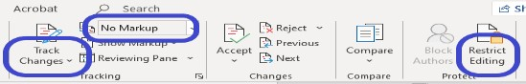

To ensure minimal levels of Section 508 compliance are met, users should use the automated Accessibility Checker functions available in documents prior to publication. This function can be found in the Review tab in Word (Figure 2 in blue) and the Tools tab in Adobe (Figure 3 in blue). If a group uses accessibility checker tools other than the tools suggested in this document, an accessibility report showing the artifact meets 508 conformance standards may be requested from the VDL Administrators.

Detailed instructions on identifying and correcting accessibility issues can be found at the SSA website, [Microsoft Word 2010 508 Accessibility Checklist.](https://www.ssa.gov/accessibility/checklists/word2010/default.htm)

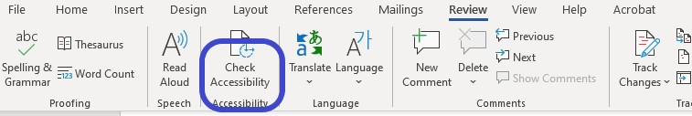

Figure 2: Check Accessibility Function in MS Office for Word

Figure 3: Accessibility Tool in Adobe For PDF

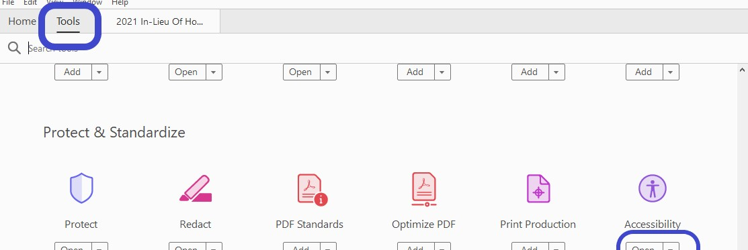

Additional guidance on making documents accessible can be found at the [VA Section 508 Office](https://www.section508.va.gov/) website.

# Document Retention Standards

Artifacts stored on the VDL are governed by the Office of Information & Technology Records Control Schedule 10-1, Chapter 2. Standards for document retention on the VDL are outlined below.

## Revisions and Versioning

Revisioning, version updates or versioning refer to the process where an artifact is replaced with an updated manual with the same internal filename, such as sr_3_um.docx for example. An artifact replaces an existing artifact through versioning ONLY if it includes the entire scope of discussion of functionality, processes, or contents which previously existed in the earlier edition.

When an artifact is replaced through versioning, the updated version must simultaneously replace the old version leaving no lapse in documentation availability on the VDL.

Revisions made to the existing manual would be shown in the Revision History at the beginning of the manual and saved as the original name, i.e., sr_3_um.docx. The revised manual would be uploaded where the current User Manual now resides.

When making edits to an existing manual, ensure appropriate coordination is done with other project teams who are also making edits to the same manual concurrently.

***NOTE****:* There should **never** be two or more versions of an existing manual on the VDL at the same time. This applies to User Guide/Manuals, Technical Manuals, Security Manuals, Installation Manuals, etc*.*

## Deletion and/or Removal of Artifacts

Artifacts stored on the VDL should not be removed. The only exceptions for artifact removal are:

1. Accessibility issues, such as corrupt files. In this scenario, the publisher of the artifact is responsible for submitting an accessible version of the document for publication to the VDL as soon as the publisher is made aware of the issue.
2. Entered in Error: If an artifact was uploaded in error, it should be removed as soon as the publishers is aware of the error.
3. Replaced through versioning as defined in Section 6.1 of this document. *The previous version is to be moved to the Archive folder.*
4. Artifact is moved to the Archive folder of the application, only after verifying the artifact has been moved and is accessible in the Archive folder.

## Archive Application Folders

Artifacts from previous versions/years will be moved into the Archive folder of the application by the publisher or the team assigned to the application. These artifacts are not to be deleted from the VDL at any point. The only time manuals, such as user or technical, should be archived is when a new version of the package is released. For example, currently Outpatient Pharmacy is Version 7.0. **IF**a new version is released as 7.1 or 8.0, **ONLY** then will the manuals be archived.

Otherwise, manuals will continue to be updated with the internal file name not changing.

## Decommissioned Systems and/or Software

Periodically, systems and/or software become decommissioned. When this occurs, the VDL Library Administrators will amend the name of the displayed name on the VDL to reflect the new status and the effective date to make users aware development has ceased for this application within the VA. An example of the updated system and/or software name would be “Electronic Wait List – DECOMMISSIONED MAR 2021”. All artifacts will be combined into the one folder.

While systems and/or software may no longer be used within the VA, users outside the VA may be using the systems and/or software, creating the requirement for the documentation to exist and remain accessible. Therefore, the artifacts relating to systems and/or software in a

Decommissioned status will remain on the VDL until a date determined by the VDL Library Administrators.

# Document Standards for End User Documents

All artifacts published in the VDL must conform to the document standards of this document. Artifacts will be reviewed by the VDL Library Administrators and if found to be not conforming to the standards outlined in this document, the publishing user will be notified by email with an attachment of VDL Document Review Findings. This attachment will list what needs to be corrected within 7 business days. After corrections have been completed, the artifact will be reloaded for publication to the VDL. It will be checked again to ensure corrections were made. If corrections were not made and reposted, the artifact will be removed from the VDL and an email sent to the user and their supervisor.

## Document Format Guidelines

While other document types are accepted for publication, documents placed on the VDL must be in both a Word document not containing macros (.docx) and portable document file (.pdf) formats at a minimum.

## Document Type Requirements

At a minimum, the following artifacts must be published to the VDL:

1. Deployment, Installation, Back-Out and Rollback Guide (DIBRG): Required end-user document for all releases of VistA software patches.
2. Release Notes: Except for the initial distribution of VistA software, Release Notes are optional. Revisions to a product involving major changes to technical specifications or end-user functionality require Release Notes. DIBRG may take the place of Release Notes in certain instances.
3. Technical Manual: Required end-user document for all OIT software releases. It provides technical content for people using a particular system/application. It is typically written by a Technical Writer, but can also be written by programmers or other technical staff.

While the Technical Manual residing on the VDL must be redacted of IP Addresses, Port Numbers and Points of Contact, the version placed on the internal software site should have these unredacted.

1. User Manual/User Guide: Required end-user document if pertinent to the software. The Project Manager, as the authoritative source and in consultation with the appropriate technical staff, determines if a User Guide is a required artifact for the project.

## Document Size Restrictions

While 32MB is the maximum artifact size for the VDL, publishers should strive to keep document sizes much lower to maintain usability for the readers. For instance, if this requires splitting a user guide into more than one document, the document name should be reflective of it having multiple sections. An example would be PIMS Version 5.3 User Guide Sections 1-6 and PIMS Version 5.3 User Guide Sections 7-10.

## Document Authorship/Properties Guidelines

Due to the VA’s prohibition on displaying sensitive data, artifacts published to the VDL must not have individual author information saved within the document text or the document properties.

Artifacts containing only the authoring VA or VA affiliated organization name are acceptable.

### Acceptable Authorship

Artifacts containing only the authoring VA or VA affiliated organization name are acceptable. Individual names must not be included in the authorship area. An example of an acceptable authoring display is shown in the figure below, outlined in blue.

Figure 4: Acceptable Author Information Example

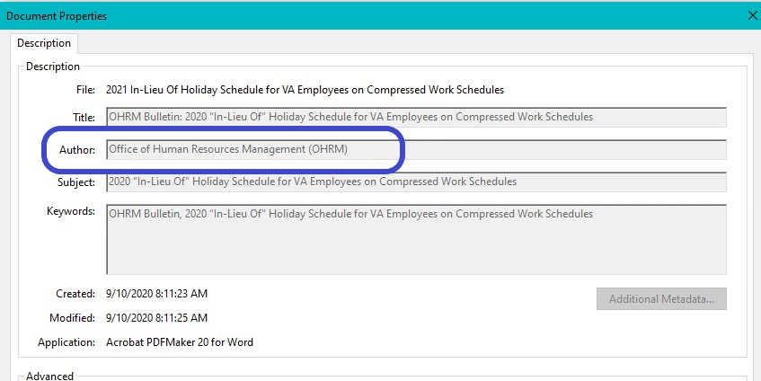

### Changing Author Settings for Microsoft

To avoid inserting an individual’s name by default in .docx artifacts, users should set their Microsoft options to display an appropriate VA or VA affiliated organization name.

#### Setting Author in .docx Options

1. Select FILE in top left corner of Word document.
2. Select OPTIONS

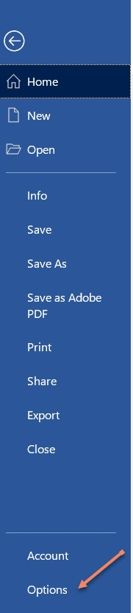

Figure 5: Options in .docx

1. In the GENERAL tab, outlined in blue, personalize Microsoft Office by changing the author to the appropriate VA organization name. Then click “Always use these settings regardless of the sign in on Office” and select OK (outlined in blue).

Figure 6: Personalize Copy of MS Office

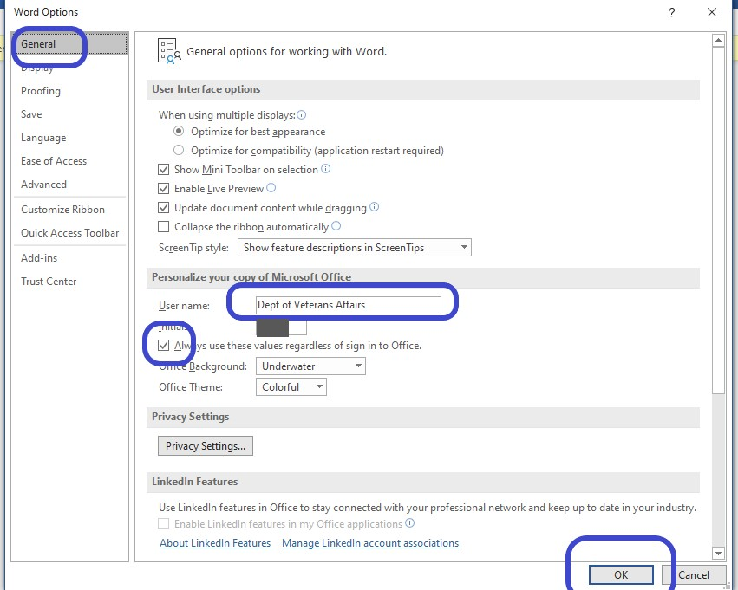

#### Document Properties/Author Information .docx Instructions

1. Select FILE in top left corner of Word document.
2. Select INFO, and verify author properties are blank.

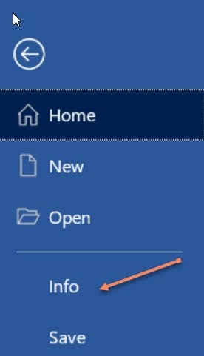

Figure 7: Select Info in .docx

1. Verify author properties are blank and last modified is either blank or has acceptable name.

Figure 8: Verify Author Properties in .docx

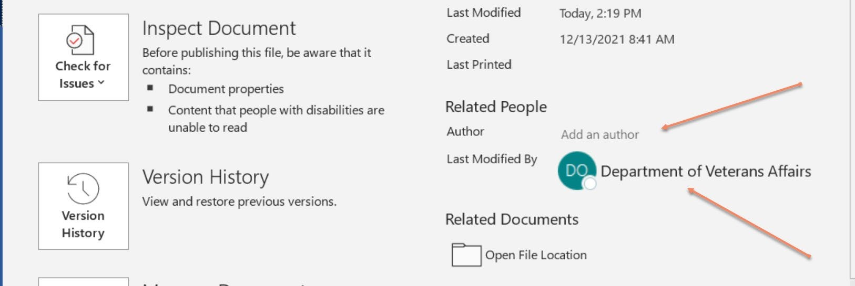

1. If an author is showing, it will need to be removed. Right click on the name and remove person.

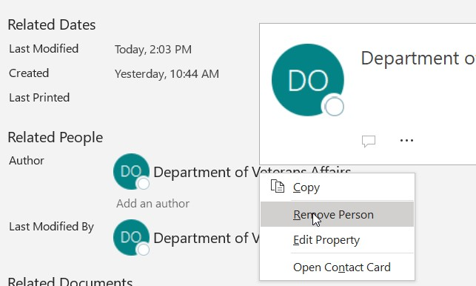

Figure 9: .docx Author Instructions

1. Or select Edit Property and replace name with acceptable information, then select OK.
2. After changes have been made, save the new version.

#### Document Properties/Author Information .pdf Instructions

1. Select ‘Enable All Features’ (if the prompt displays when the file is opened).

Figure 10: .pdf Author Instructions

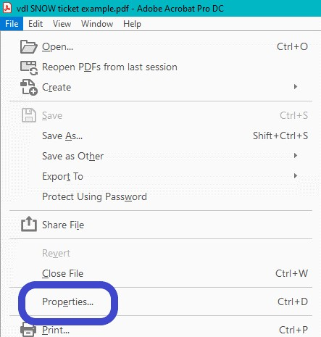

1. Select File located in top left corner of document and select Properties,
2. Edit or remove the Author name and select Ok, Figure 30 outlined in blue.

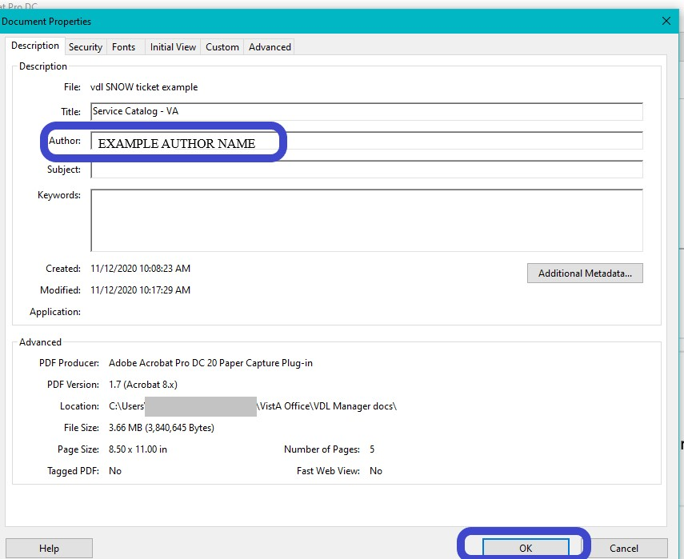

Figure 11: Edit .pdf Author

## Internal File Naming Conventions

The term filename refers to the internal name of an artifact. Filenames must be concise and be comprised of a maximum of 30 characters, the dot, and a three or four character extension, with no spaces between the elements. An underscore separates each element of the document filename. Follow the guidelines below to create filenames.

***NOTE:*** The filename for the same manual designated for upload to the directories other than the VDL may be different based on the conventions required by the Project Support Release Manager. The filename used by project teams can follow team-specific naming guidelines prior to publication to the VDL; however, when the artifact is placed on the VDL, it must adhere to the File Naming Conventions as outlined in this document.

***NOTE:***If there are already manuals for a version, such as user, technical, etc., then the internal name of the replacement file **MUST BE** the same as the original version. For example, if sr_3_0_um already exists, then the replacement file must also be sr_3_0_um. There are **NO EXCEPTIONS**. If original file name changes are detected, it must be corrected immediately.

1. **Filename**: **Must** be lower case; no spaces allowed; use underscores. This also applies to the includes the extension abbreviations (.docx and .pdf).
2. **Package Namespace**: The first element of the filename is the approved package

“namespace” for the associated patch. For example, psb for BCMA and sr for Surgery.

1. **Software Version**: The second element of the filename is the software version number. It is one or two digits in length and does not include a zero, even if the actual package version number includes this digit. For example, V.3.0 or Version 3.0 would be listed as “3_” and V.3.1 or Version 3.1 would be listed as “3_1”. In “3_1”, the second digit refers to a point release. A point release would happen when several major updates are made to the package, but not a complete rewrite of the package. The version would go from 3.0 to

3.1.

1. **Document Type**: The third element of the filename is the abbreviation for the document type. For example, the filename for the original Surgery Version 3.1 User Manual would be **sr_3_1_um**. Some examples of document type abbreviations are listed below.

|  |  |
| --- | --- |
| **Known Document Acronym** | **Description** |
| api | Application Programming Interface Manual |
| dg | Developer’s Guide |
| dibrg | Deployment, Installation, Backout and  Rollback Guide |
| gs | Getting Started Guide |
| ig | Installation Guide |
| qr | Quick Reference card/guide |
| rm | Read me file |
| rn | Release Notes |
| sg | Security Guide |
| sp | Supplemental Patch documentation |
| tm | Technical Manual[5] |
| ug | User Guide |

1. Redaction Indicator: This element is optional and was requested by several users in order to separate redacted vs unredacted documents. However, if the current document is replacing an already existing document, user guide for example, the _r will not be able to be used. The new document must have the same file name as the preexisting document, therefore using _r is not to be used. On new artifacts, for instance DIBRG, using the _r is acceptable.
2. File Extension: This is the last element of the file name.
   1. Accepted file types: txt, pdf, doc11, rtf, zip, docx
   2. For Word documents, the extension should be .docx

* 1. For Adobe Acrobat documents, the extension should be .pdf
  2. Filenames cannot have spaces or extra dots/period in the name. Use underscores.

1. The following are examples of, but not limited to, a typical file naming convention for a Fee Basis VistA Technical Manual based on the details outlined above.
   1. fee_3_5_dibrg.pdf
   2. fee_35_dibrg.pdf
   3. fee_35_tm.docx
2. Unacceptable internal naming convention would be as follows. There should never be a patch number in the original guides or manuals for the package.
   1. fee_35_p45_tm
   2. pso_7_0_p600_um

## External Document Naming Conventions

The term document name refers to the external facing title of an artifact. Document naming shall occur using the naming standard outlined in this guide using upper and lowercase, as appropriate.

Document names will reflect the Application/Package Name, the Version number, and the document type (example: Installation Guide, Technical Manual, etc.). Documentation for patch releases should have the Patch Number followed by the document type, unless it is to signify an update to an already existing manual.

1. Accepted Naming Format examples
   * DG*5.3*1006 Release Notes
   * DG*5.3*1006 Install Guide
   * DG*5.3*864 DIBRG
   * PIMS V. 5.3 Technical Manual (updated DG*5.3*1006)
   * PIMS Version 5.2 Technical Manual (updated DG*5.3*1006)
2. Unaccepted Naming Format examples
   * Installation Guide – DG*5.3*864
   * Installation Guide (DG*5.3*864)
   * DG*5.3*1006 RELEASE NOTES[6]
   * PIMS Technical Manual[7]

# Using the VDL Manager

The VDL Manager is an application internal to the VA used to update and maintain the documents found on the VDL.

This section provides the instructions on obtaining access and the basic add/replace/edit/delete practices for using the VDL Manager (intranet) to publish end-user documentation to the VDL (internet).

***NOTE/WARNING****: ALL the documents on the VDL web site can be accessed by anyone on the internet. Prior to publication to the VDL, review all artifacts to ensure they do not contain prohibited or restricted information.*

## VDL Manager Access

To gain or edit existing access to the VDL Manager, follow the steps listed below.

1. Use the link, [VDL Service Management](https://dvagov.sharepoint.com/sites/OITEPMOVistAOffice/SitePages/VDL-Service-Management.aspx) , to obtain the [VistA Office - VDL Service Request Form,](https://dvagov.sharepoint.com/sites/OITEPMOVistAOffice/SitePages/VDL%20Service%20Request%20Form.aspx) to either request access for a new user or to edit an existing user’s access. When making requests, ensure the correct request type is checked.

Figure 12: VDL Manager Service Request Form

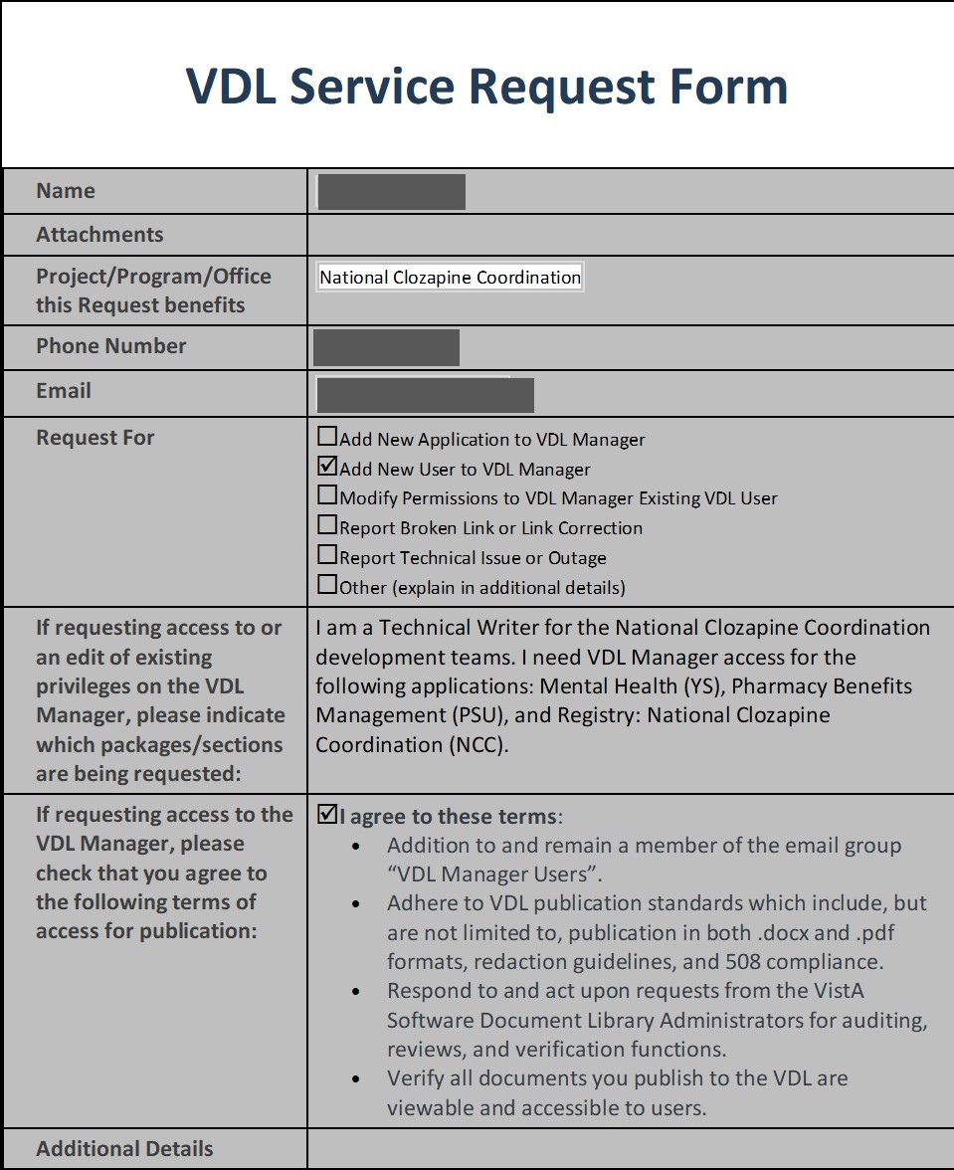

1. The VDL Administrators will receive an email with the above information. They will respond on the email requesting the user forward the email to their approving official for approval. Approval from the requestor’s project/program manager/supervisor will be required to obtain access to a specific package and/or application.
2. The approving official should reply to all on the email thread with the approval or disapproval.
3. Once access is approved, the following actions take place:
   1. User’s information will be added/edited to the VDL Manager.
   2. New users will be added to the VDL Managers Distribution Group
   3. Quarterly VDL Managers meeting will be forwarded to new users
   4. A copy of the current version of VA Software Document Library (VDL) Manager: User Guide will be attached to the email thread with the response the user has been added.
   5. Edited users will be notified of changes on the same email thread. E. Users then follow this link to the VDL Manager interface: <https://vdlmanager.vdl.vaec.va.gov/vdl>

F. When access to the VDL is no longer required, it is requested the employee or the supervisor send a notification to the VDL Administrators requesting access be removed.

## Using the VDL Manager

The first screen welcomes the user to the VDL Manager.

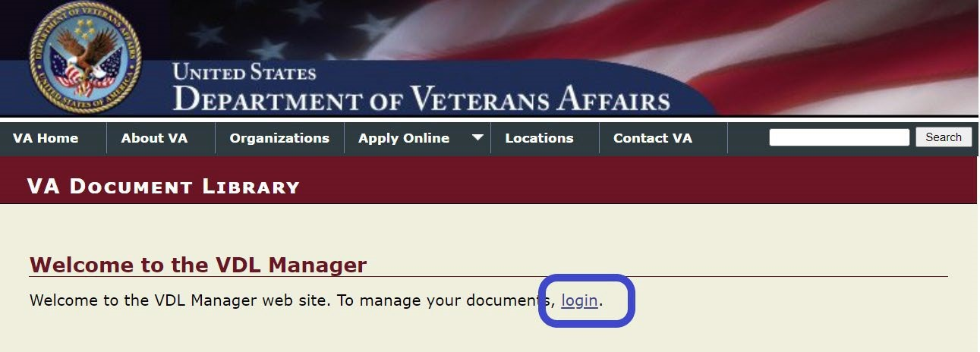

Figure

13

:

VDL Manager Home Screen and Login

Click the login link to take the user to the home page where ONLY the list of applications approved for access will be displayed.

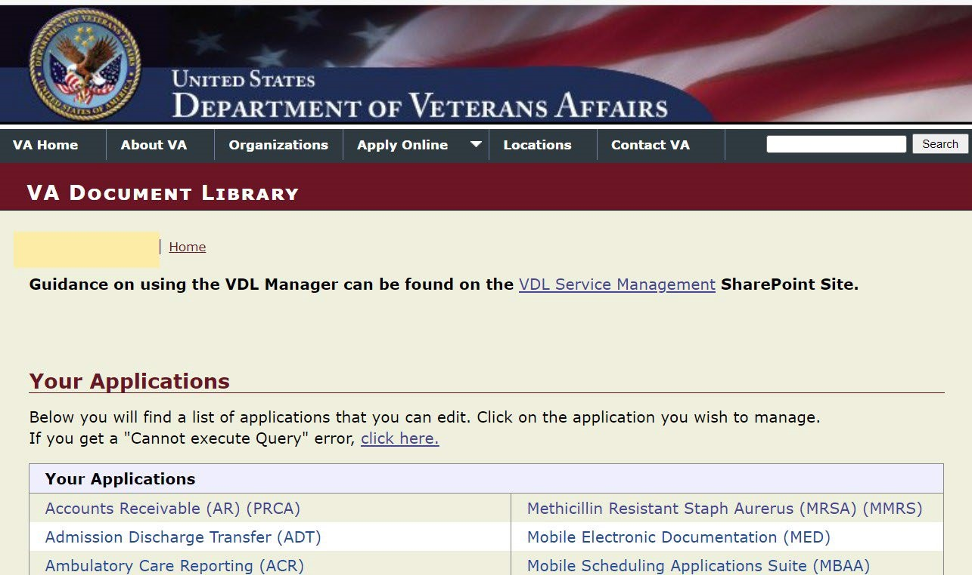

Figure 14: VDL Manager Home Page with List of Application Links

## Managing Artifacts/Documents on the VDL Manager

The user can now manage the artifacts stored in the VDL. Follow the steps listed below to access the specific application assigned.

1. Select the appropriate package/application from the display of available applications. (see Figure 14).
2. The VDL Manager will display the specific application’s page

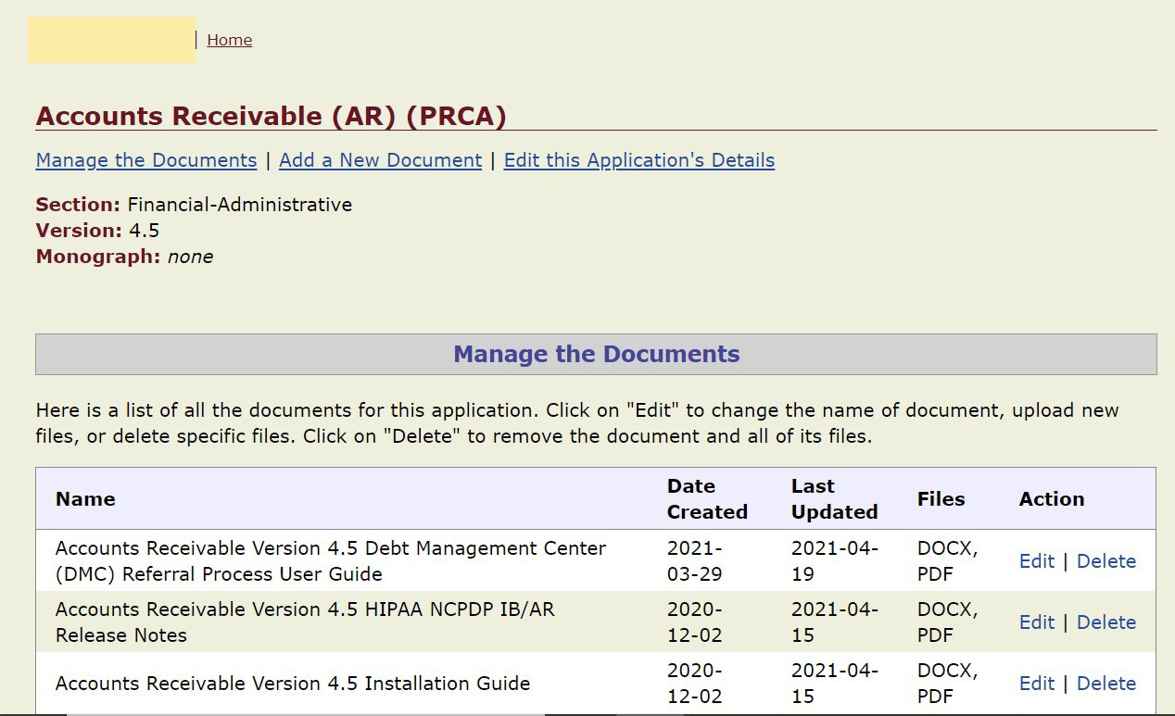

Figure 15: Typical Application Display

1. From this section, the user can add, edit, replace and delete end-user documentation on the VDL.
2. From this area the user can jump directly to Manage the Documents, Add a New Document or Edit this Application’s Details. Documents can also be managed by selecting Edit from the list in the rightmost column, Action.

### Adding a New Artifact/Document

When new documentation is needed to be published on the VDL (i.e., new packages, software updates not reflected through versioning, or patch release, etc.), Add A New Document would be used.

Follow the steps below to Add a New Document

1. Select the Add a New Document link on the home page. This brings the section into view to perform this action.

Figure 16: Add A New Document Link

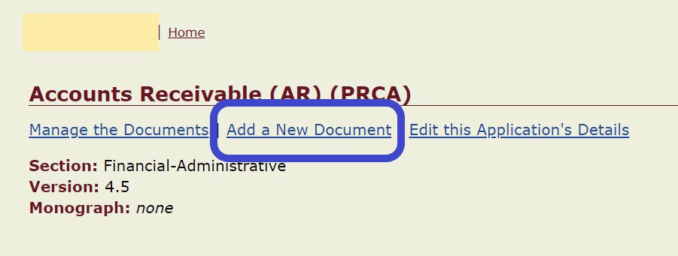

1. Follow the steps in the next figure. Ensure the external naming convention are followed when typing in the Document Name.

Figure 17: Add A New Document

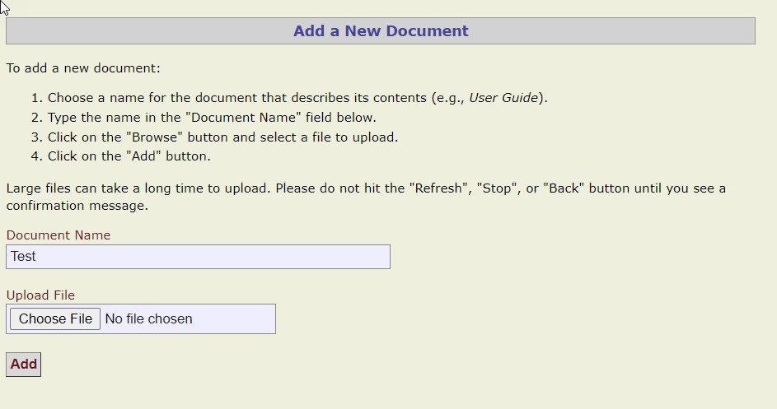

1. Upload either the .docx or .pdf version. Once the first one has been loaded successfully, then upload the next one. The VDL Manager only allows the uploading of one item at a time.
2. Once the document has been loaded successfully, the user will be automatically redirected to the original page and see the message shown in Figure 18.



Figure 18: Document Uploaded Successfully Message

1. In the event the error message shown in Figure 19 is received, ensure there are no have spaces between the words and the entire name, including the extension) is in lowercase. If the error continues, contact the VDL Adminstrators.

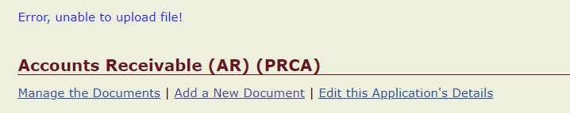

Figure 19: Unable to Upload File Message

1. To add the next document, locate the document added in previous steps and click on Edit



Figure 20: Add Next File to Document

1. Follow steps C -D again.
2. Visually verify both versions are uploaded.



Figure 21: Verification Both Files Are Loaded

1. The VDL Manager recognizes documents sharing the same name and in a different format (.docx or .pdf) as separate artifacts. Files can share the same name provided they are in different formats on the VDL. However, the VDL Manager prevents having the same document in two different entries on the same application page.

### Editing an Existing Artifact/Document

Selecting the Edit link, opens three options for editing: Upload, Edit, Delete. This option would be used to update an existing manual or reload a manual needing correction. This document must have the same internal file name as the document being updated., i.e., sr_3_tm.docx.

***NOTE:*** *The VDL Manager software only uploads an existing file based on the existing name. If the file or document name is changed, the software will not allow you to replace the file.*

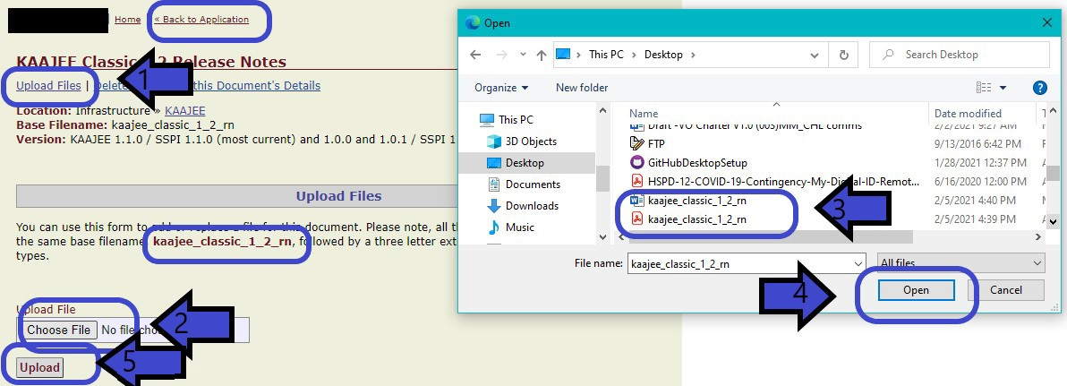

Figure 22: Upload Files Screen Showing Base Filenames are the Same

1. Upload the document from your workstation.
2. After uploading the file, the date *Last Updated,* appears next to the title of the manual.

Figure 23: Last Updated Date Displayed

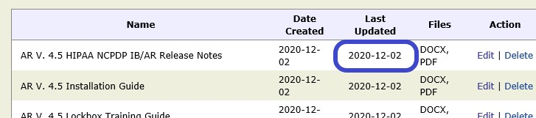

### Deleting an Existing Artifact/Document

As stated before, this option should ONLY be used to remove documents which are replaced through versioning, accessibility issues, such as corrupt files or after files have been moved to Archive folders.

There are two ways to delete documents. One will remove the entire “file” including the external name and documents. The other will remove only the document requested.

***NOTE:*** *Deletions cannot be recovered – there is no backup of the VDL.*

#### Delete ALL Documents

This allows deletion of the entire entry, including all documents.



Figure 24: Delete an Existing Entry, Including ALL Documents

When selection this option, the pop-up shown in Figure 25 appears. As stated, taking this action will delete ALL files including the external name:

Figure 25: Deletion Warning of Document and ALL Files

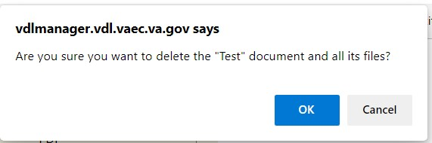

#### Delete One Document Using the Edit page

This option allows deletion only one of the documents and retain the external name.

Figure 26: Delete Files from Edit Page

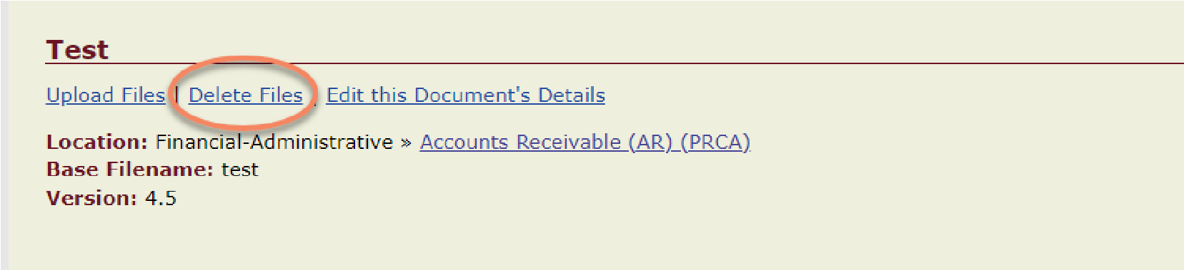

As in the previous scenario, a pop-up warning appears.

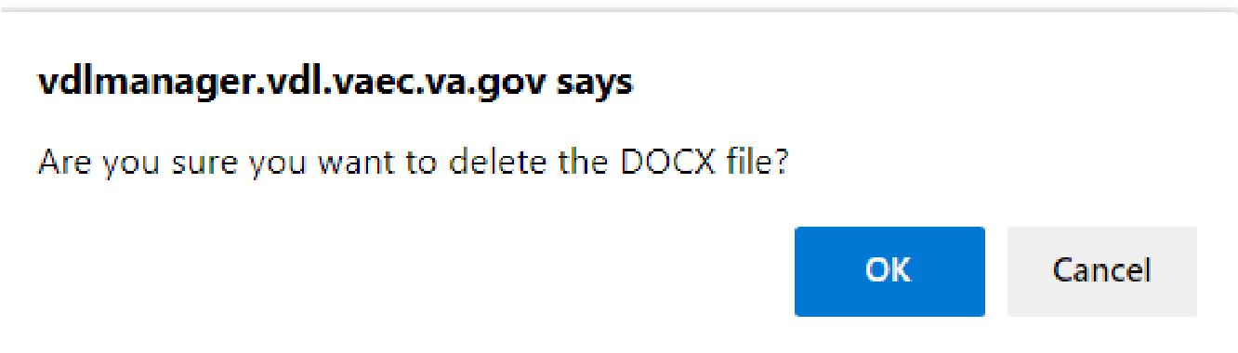

Figure 27: Deletion Warning of One File

## Moving Artifacts to Archive Folders

During the life of the VistA Application, it may be necessary to move older/historical files to the Archive Folder. Moving artifacts to the Archive is at the discretion of the authorized users of the application in the VDL Manager, technical writers, project managers, and/or team members for the specific application. The moving of these artifacts will be done by the authorized user assigned to the application. The only time the VDL Administrators will move files is when the application has been decommissioned and all artifacts need to be moved to one folder.

Moving artifacts involves several steps and needs to be followed closely to ensure historical artifacts are not lost.

1. Navigate to the VDL public facing site, [VA Software Document Library](https://www.va.gov/vdl/)
2. Select the Section where the application resides
3. Locate the folder with the files needing moved
4. Download the 2 files (.docx/.pdf) to your local machine
   * The VDL Administrators suggest creating a folder on your machine to temporarily house these artifacts
   * Ensure the files are redacted at this time E. Make note of the external file name.
5. Sign into VDL Manager and locate the Archive folder
6. Add a document using the steps above. **Keep** the external and internal names the same
7. Upload the two files into the Archive folder
8. Once the publication process is completed, go into the VDL again to verify the files were

published and are accessible/will open. **THIS IS VERY IMPORTANT – DO NOT SKIP**!

1. On the email thread, respond the files have been verified
2. Sign into VDL Manager and locate the original folder
3. Delete the documents from the original folder
4. Delete the file from your machine
5. A second publication process will occur for the removal of the deleted files. When the second process is complete, go into the VDL again to verify the files were removed.

asked to verify the files have been deleted

## Editing Application Details

The option, Edit this Application’s Details, allows users to edit the software application’s name and version number. This option would be used when the software application’s name or version number changes, such as when Joint Legacy Viewer was renamed Joint Longitudinal Viewer.

To edit the application details as they appear on the VDL:

1. Select the Edit this Document’s Details link

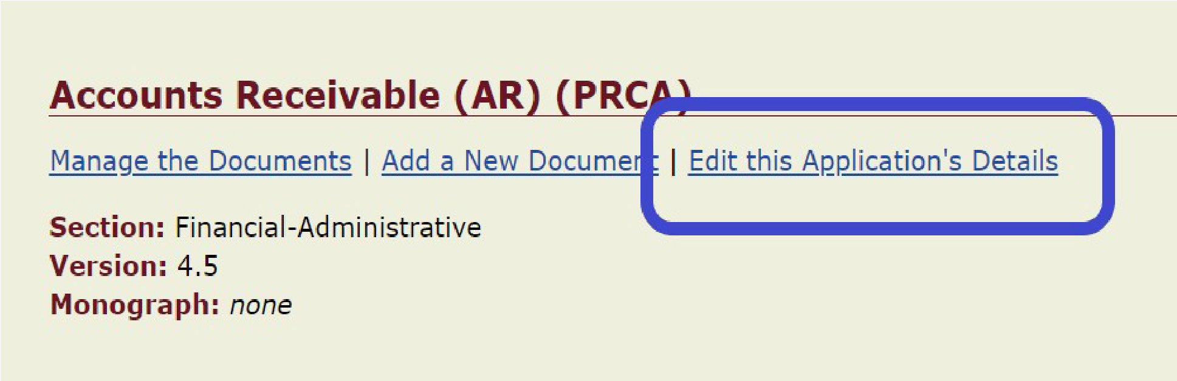

Figure 28: Edit this Application's Details

1. Edit the field needing changed first, and then click the Edit button to save the changes

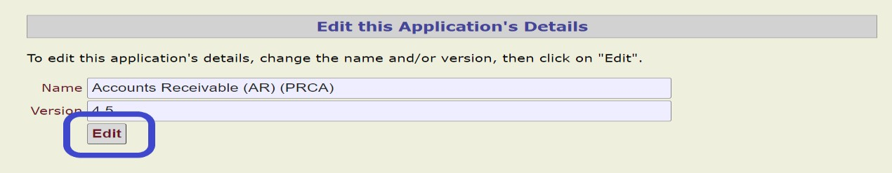

Figure 29: Editing the Name and/or Version Information

# Publishing Process: Promoting Artifacts from VDL Manager to the VDL

The task of promoting artifacts from the Staging (VDL Manager) to the Production server (VDL) involves an automated process and manual intervention to act on the results of that process. The automated process occurs three times a day Monday-Thursday (6a.m., 11 a.m. and 3 p.m.) and twice on Friday (6 a.m. and 11 a.m.). This process compares the Staging area data to the Production area data. If differences are detected, the steps listed below will occur.

***NOTE:***  Promoting artifacts can take 6 to 24 hours to process. Please plan releases accordingly.

1. After items have been uploaded, edited or deleted from the VDL Manager, an email entitled “VDL Publish to Prod” will be automatically generated to the VDL Administrator’s mail group. This notifies them to begin the promotion process by entering a Service Now (SNOW) ticket. You, as the publisher, will also be a recipient of this email.

Figure 30: Automatically Generated Email

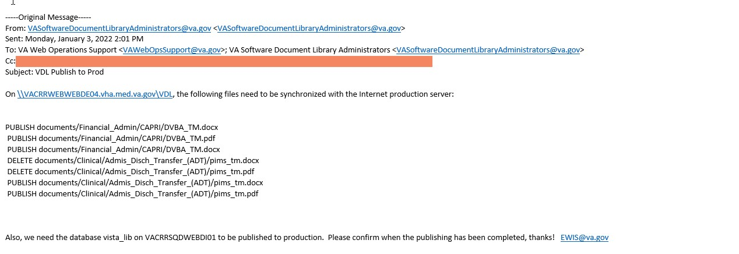

1. A member of the VDL Administrator’s mail group will submit an incident SNOW ticket to promote the documents. After this occurs, the ticket initiating group member will respond on the original email thread with the ticket number, INC#########.

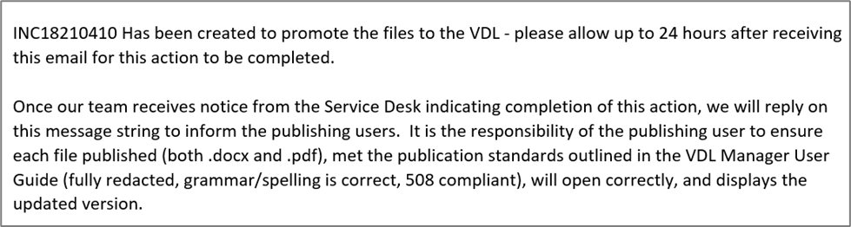

Figure 31: Response on Original Email with Incident Ticket Number

1. When the incident ticket has been resolved, the VDL Administrator group member will receive a message the ticket has been resolved. At this time, they will respond on the email thread to the publisher indicating the artifacts have been promoted and are available on the VDL. An example of this second response is shown in Figure 32.

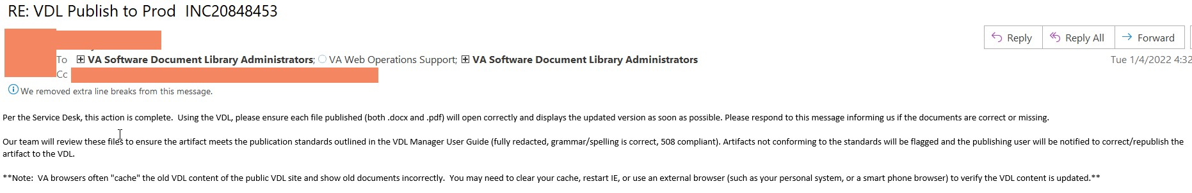

Figure 32: VDL Administrator Email Reponses when Ticket has been Resolved

1. Within three (3) business days of receiving confirmation, it is the responsibility of the publishing user to verify all versions of the documents are posted correctly and are viewable on the VDL website without corruption or errors.
2. After the documents are promoted, the VDL Administrators will review the documents to ensure they meet the publications standards outlined in this User Guide, including but not limited to: appropriate redaction, grammar/spelling, 508 compliant, correct internal filenames and correct external name format. If any issues are found, the publisher will receive a “VDL Document Review Findings” report with items needing to be corrected.

***NOTE****: If an initial email message* *entitled “VDL Publish to Prod” is not received by the end of the day after uploading documents to the VDL Manager, please contact the VDL Administrators.*

# Errors and Getting Help

If you have any questions, please email the VA Software Documentation Library Administrators or submit a service request to the team using the form on the [VDL Service Management](https://dvagov.sharepoint.com/sites/OITEPMOVistAOffice/SitePages/VDL-Service-Management.aspx) SharePoint site.

# Documentation Disclaimer

The appearance of external hyperlink references in this manual does not constitute endorsement by the Department of Veterans Affairs (VA) of this Web site or the information, products, or services contained therein. The VA does not exercise any editorial control over the information you may find at these locations. Such links are provided and are consistent with the stated purpose of the VA.

# Glossary

|  |  |
| --- | --- |
| **Acronym** | **Definition** |
| API | Application Programming Interface |
| DIBRG | Deployment, Installation, Back-Out and Rollback Guide |
| FOIA | Freedom of Information Act |
| FQDN | Fully Qualified Domain Names |
| FTP | File Transfer Protocol |
| ICT | Information and Communication Technology |
| IP | Internet Protocol Address |
| NOK | Next of Kin |
| PHI | Personal Health Information |
| PII | Personally Identifiable Information |
| ROB | VA National Rule of Behavior |
| RTT | Rational Tools Teams |
| **Acronym** | **Definition** |
| SP | SharePoint |
| SSN | Social Security Number |
| URL | Uniform Resource Locator |
| VA | Department of Veterans Affairs |
| VDL | VistA Document Library |

# References

* VA Software Document Library (VDL) Manager: User Guide Version 3.0, June 2021
* Displaying Sensitive Data Guide, August 2019
* Developing Handouts in Microsoft Word for Final 508 Compliance Reference

Handout, IT Workforce Development, 2017

* Documentation Style Guide, February 2021
* EPMO CMO Standard File Naming, June 2020
* Information and Communication Technology, Revised 508 Standards and 255 Guidelines, January 2018
* Office of Information &Technology Records Control Schedule 10-1, January 2020
* OIT End-User Documentation Standards, February 2021
* OIT Written Communication Guidance, October 2017
* M-13-13, Open Data Policy-Managing Information as an Asset, May 2013
* VA Directive 6500, VA Cybersecurity Program, February 24, 2021
* VA Handbook 6500, VA Cybersecurity Program, February 24, 2021
* VA Directive 6502, VA Enterprise Privacy Program, May 2008Social Security Administration (SSA) Microsoft Word 2010 508 Accessibility Checklist, website, n.d.

# Attachments

Please use the following checklists to ensure all items are correct prior to and after posting.

These checklists are only intended as a reference. Additional information is included in the VDL User’s Guide. Please refer to it for additional instructions or contact the VDL Administrators at vasoftwaredocumentlibraryadministrators@va.gov.

Please note, redaction standards apply to all text in an artifact to include screenshots, graphics, and examples.

Personally Identifiable Information (PII) defined in OMB Memorandum M-07-1616, Port Numbers, IP addresses, URLs, Fully Qualified Domain Names (FQDN), Mail Groups used to receive data, and any other sensitive information identified in the “Displaying Sensitive Data Guide” cannot be included in artifacts published external to the VA. (End User Documentation Standards, Dec 2019).

The checklist development was a coordinated effort with the VDL Administrators, several senior technical writers, and other subject matter experts.

## Attachment 1 Quick Artifact Content Checklist - Prior to Posting

**.docx Checklist**

☐ 1. Was the .docx redacted of the following?

☐ A. Are all patient and employee names, initials and other information which identifies an individual (email address, phone number, physical address, professional license numbers, provider numbers / license numbers, clinic names which include provider / employee name, RX#s, Cardholder ID, DOB, ECME#s, PIDs, etc.) removed or redacted from all text, graphics, and figures?

Examples of **ACCEPTED** Version:

Patient name – PATIENT, ONE <or> GJAWER, FCOAWEA

Employee name – PROVIDER, ONE <or> ASDFKGAS, FWEFA

Clinic name – Actual name of clinic in VistA (Pulmonary, Medicine) or

TESTCLINIC

SSN – 000-00-0001 <or> XXX-XX-9999 <or> XXX-XX-XXXX

Email address – PROVIDER.ONE@YOURSITE

Examples of **UNACCEPTED** Version:

Patient Name – Duck, Daffy <or> Smith, John

Employee Name – Duck, Daffy <or> Smith, John

Clinic Name – John’s Clinic

SSN – Any combination of real numbers creating the appearance of legitimacy

Email address – SMITH.JOHN@VA <or> PROVIDER@MED.VA.GOV

☐ B. Are all internal sources and settings, such as IP / servers addresses, internal site addresses (ex. SharePoint) and other prohibited information removed redacted from all text, graphics, and figures? Remove anything containing va.gov, vha,

vaaec, etc.

Examples not allowed: \\vaauspecdbs801.aac.dva.va.gov\AITC\IEPeRx\v.4.0\deployments and [Index of /index.html/SOFTWARE (va.gov)](https://gcc02.safelinks.protection.outlook.com/?url=https%3A%2F%2Fdownload.vista.med.va.gov%2Findex.html%2FSOFTWARE%2F&data=04%7C01%7C%7C828c5c638f9b4692394008d9c0e6bf50%7Ce95f1b23abaf45ee821db7ab251ab3bf%7C0%7C0%7C637752919541771030%7CUnknown%7CTWFpbGZsb3d8eyJWIjoiMC4wLjAwMDAiLCJQIjoiV2luMzIiLCJBTiI6Ik1haWwiLCJXVCI6Mn0%3D%7C3000&sdata=dNFhyE3uO9crlo%2FE0TsKvTag9BUK7%2Fl5O4rNWScQmsI%3D&reserved=0)

* Download/ftp site addresses (Albany, Hines, SLC, etc.)
* Port numbers
* Server names and/or address
* Intranet site addresses and/or links
* SharePoint Site addresses and/or links
* Phone numbers • Email addresses

|  |  |
| --- | --- |
| ☐ 2. | Are the authoring data / names reviewed and / or removed, as appropriate? Remove names and / or initials – only company names are allowed. (Metadata and / or Revision History) |
| ☐ 3. | Are the last modified data/names reviewed and/or removed, as appropriate? Reminder to remove names, signon login name (alias), initials – only company names are allowed. |
| ☐ 4. | Is document checked for spelling, grammar, etc.? Reminder to ensure VistA is spelled correctly. |
| ☐ 5. | Are any watermarks removed? |
| ☐ 6. | Are any references to test versions of patches removed, including on the Title/Cover page? |
| ☐ 7. | Are all changes accepted under Track Changes? Was Track Changes function turned off? |
| ☐ 8. | Is the .docx set to “No Markup”, including ALL comments have been removed? |
| ☐ 9. | Is “Restrict Editing” removed? |

☐ 10. Is password protected off?

☐ 11. Is Read Only is OFF?

☐ 12. Are Show/Hide paragraph markers OFF?

☐ 13. Does the .docx meet Section 508 Conformance when performing the following tasks:

☐ A. Is the .docx without errors when the appropriate accessibility checker runs?

☐ B. Are external web addresses and hyperlinks active and functioning?

☐ C. Do images have Alt Text as needed?

***NOTE***: Any image used to further explain a process to the reader MUST contain

Alt Text (i.e., not marked as “Decorative”)

☐ D. Are blank formatting lines removed?

**.pdf Checklist**

|  |  |
| --- | --- |
| ☐ 1. | Is the .pdf redacted from all text, graphics, and figures?  ☐ B. Are all internal sources and settings, such as IP/servers addresses, internal site  addresses (ex. SharePoint) and other prohibited information removed redacted from all text, graphics, and figures? Remove anything containing va.gov, vha, vaaec, etc. |
| ☐ 2. | Are the authoring data/names reviewed and/or removed, as appropriate? Remove names and/or initials – only company names are allowed. |
| ☐ 3. | Does the .pdf meet Section 508 Conformance when performing the following tasks:  ☐ A. Is the .docx without errors when the appropriate accessibility checker runs?  ☐ B. Are external web addresses and hyperlinks active and functioning?  ☐ C. Do images have Alt Text as needed?  ***NOTE***: Any image used to further explain a process to the reader MUST contain  Alt Text (i.e., not marked as “Decorative”)  ☐ D. Are blank formatting lines removed?  ☐ E. Are headers, tables, etc., corrected?  ☐ F. Are Comments, Formatting Marks, and Track Changes functions off? |
|  |  |

## Attachment 2 Quick Artifact Property Checklist - Prior to Posting

☐ 1. Are there two versions of the artifacts (.docx and .pdf) and they have passed all steps in the content checklist to ensure they are ready for uploading?

☐ 2. Are the artifacts in accordance with the document standards found in the VDL User

Guide?

☐ A. Is the internal file name in lower case, no spaces, but underscores or underbars, and has the extension of .docx or .pdf?

☐ 1). Internal file name has the approved package namespace

☐ 2). Internal file name has the correct software version.

☐ 3). Internal file name has the correct document type, i.e., um; tm, etc.

☐ B. Was redaction completed, including authoring?

☐ C. On the VDL Manager, are you adding a NEW artifact or replacing an EXISTING

artifact?

|  |  |
| --- | --- |
| ☐ 1) | If replacing an existing artifact  ☐ a. Does the internal filename match what is already there?  i.e., sr_3-1_um.docx or .pdf?  ☐ b.) Was Revision History of the existing artifact checked to ensure the  document contains all the previous revisions?  ☐ c.) If needed, the wording of the external name can be changed to  include the patch number. For example, the external name may now be Outpatient Pharmacy Version 5 User Manual (updated Patch PSO*5*###). |
| ☐ 2) | If adding a new artifact |

☐ a. Verify this file is not already present.

|  |  |
| --- | --- |
| ☐ b. | In the space, “Document Name” ensure the name entered follows the naming guide, i.e., DG*5.3*1006 DIBRG |
| ☐ c. | Upload the .docx artifact. Once you’ve received the message indicating it was uploaded successfully, go to the next step. |
| ☐ d. | Find the external name just created and select EDIT. |
| ☐ e. | Upload the .pdf artifact. |
|  |  |

## Attachment 3 Quick Artifact Checklist - After Posting

As soon as an email is received from the VDL Administrators, go to the VDL (not the VDL Manager) to verify the following within 3 days:

|  |  |
| --- | --- |
| ☐ 1. | Verify each artifact (both docx and pdf) can be opened. |
| ☐ 2. | Verify the correct/newest artifact (both .docx and .pdf) has uploaded. |
| ☐ 3. | Verify names and other redactions are correct. |
| ☐ 4. | If an HTTP 500 error is received, please report it on the email thread |

## Attachment 4 VDL Document Review Findings

|  |  |
| --- | --- |
| **External Document name:** |  |
| **Internal File name:** |  |
| **Date Posted to the VDL:** |  |
| **Person and date contacted:** |  |

In accordance with the VDL Manager User Guide, please correct the following items: .docx

|  |  |  |
| --- | --- | --- |
| **Item** | **Page** | **Discrepancy Found** |
|  |  |  |
|  |  |  |
|  |  |  |
|  |  |  |

.pdf

|  |  |  |
| --- | --- | --- |
| **Item** | **Page** | **Discrepancy Found** |
|  |  |  |
|  |  |  |
|  |  |  |
|  |  |  |

Once requested action is taken, please repost the artifact to the VDL within 7 days of the date contacted listed on this notice and respond to the email in order to notify VDL Administrators of action taken. Files not corrected and reposted will be removed from the VDL. You and your supervisor will be notified of the removal.

If you have any questions or concerns regarding this request, please contact the VA Software Document Library Administrators.

Thank you.

1. Reference materials include, but are not limited to: User Guides/Manuals, Release Notes, and Instructional Guides for Technical, Security, Setup and Deployment, Installation, Backout and Rollback (DIBR) processes. 2 Artifacts, files, documentation may be used interchangeably throughout this guide.
2. Note: some packages/applications have specific requirements for example patient/employee names. If so, please follow those standards.
3. At no time should an example name create the look of a legitimate name.
4. At no time should an example phone number create the look of legitimacy.
5. tm may be used for a combined Technical Manual and Security Guide 11 doc is an older version of MS Word and should no longer used.
6. Name is not to be in all caps
7. Version is missing from this name